Mandeville, LA - This is the Dew Drop Jazz Hall in Mandeville, about 2 blocks from our condo. It is believed to be the oldest jazz and dance hall in the world. The Dew Drop Social and Benevolent Association was founded in 1885 by a civic-minded group of African Americans and they built this building, finishing it in 1895. Many of the jazz greats played here. They would boat across Lake Ponchartrain from New Orleans. More on it can be found here and here.
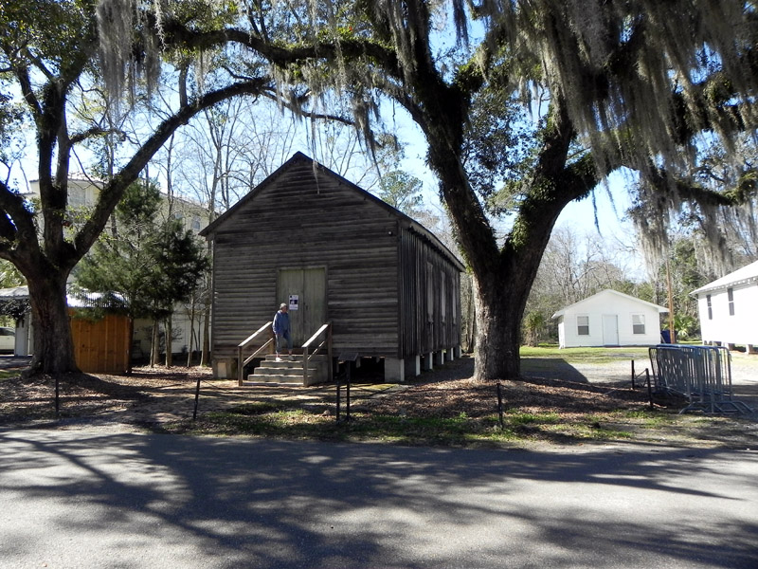
It was purchased and donated to the city by Jinx Vidrine, the owner of our condo. It is still used to this day.
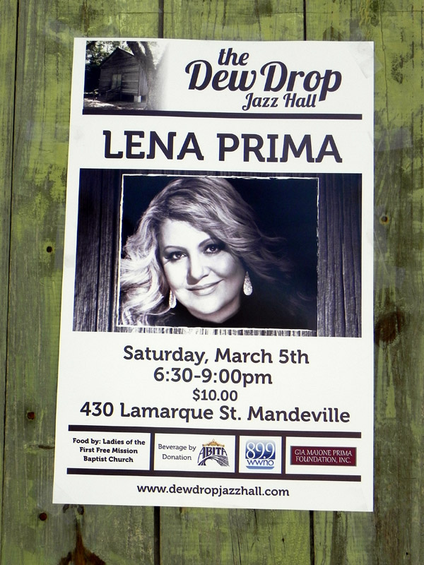
Waveland, MS - Debby in front of our new home for a month. It’s right on the beach in Waveland, MS and you can get a street view here . You can rotate the view for a 360 look. Three videos are here.
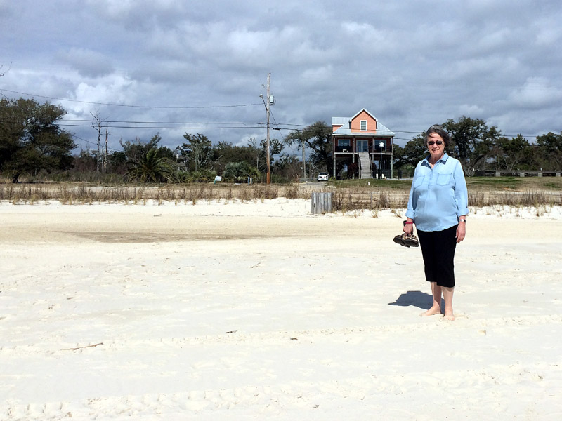

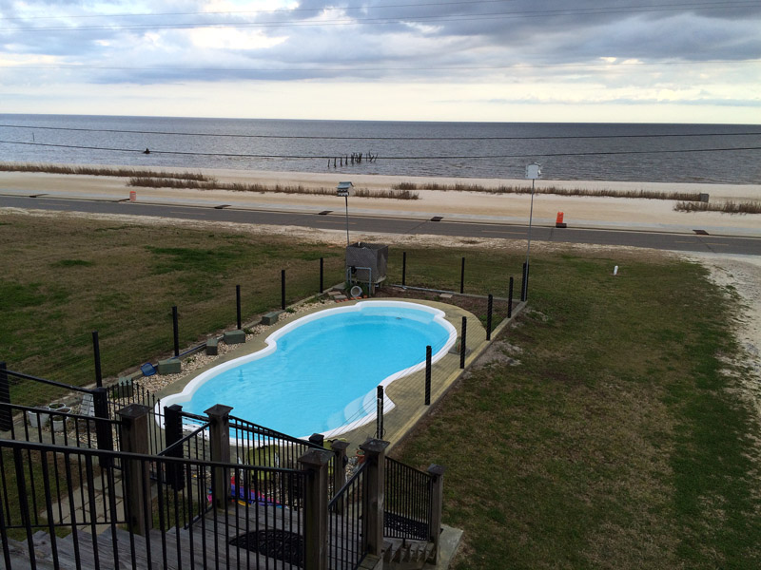
Relaxing after a tough day of beach combing.
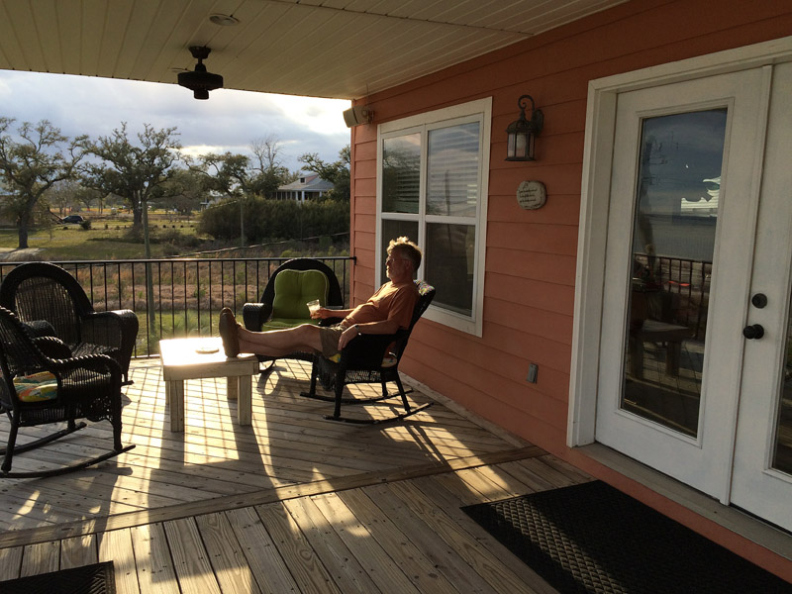
One of the first sunrises.


Another
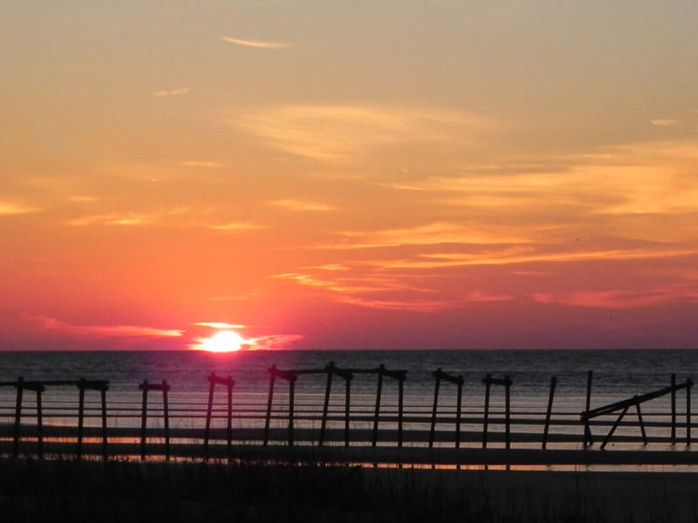
And another
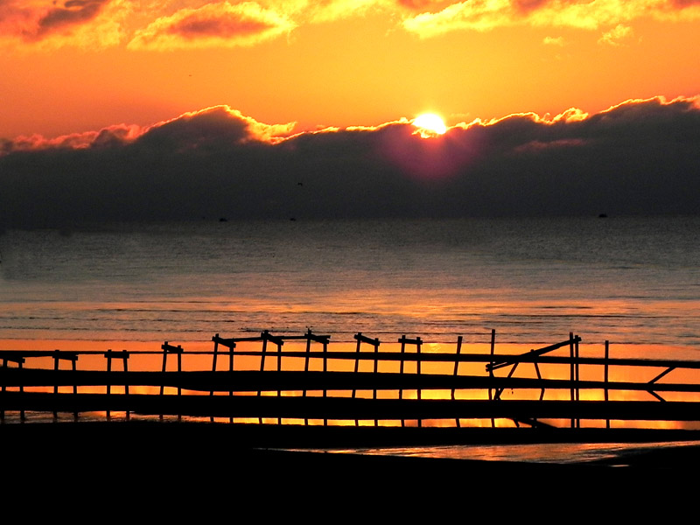
Oyster Throwdown - so, how many oysters can you throw down in one afternoon? This was a competition between about 20 businesses, all vying for your vote to win bragging rights for the best oyster recipe. Oysters were fried, baked, grilled, served on the half shell with secret sauces, added to lasagna, made into bisque, etc. It was all you could eat of whatever you wanted. There were no bad entries and it was a lot of fun. Oyster bisque (it was awesome) won 1st place. You can see a short video here.
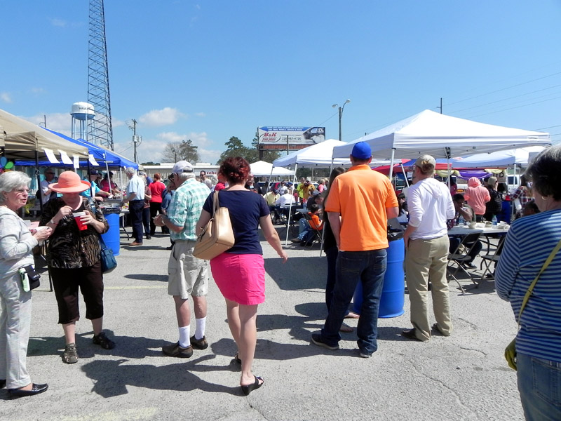
Fried oysters and oyster dressing
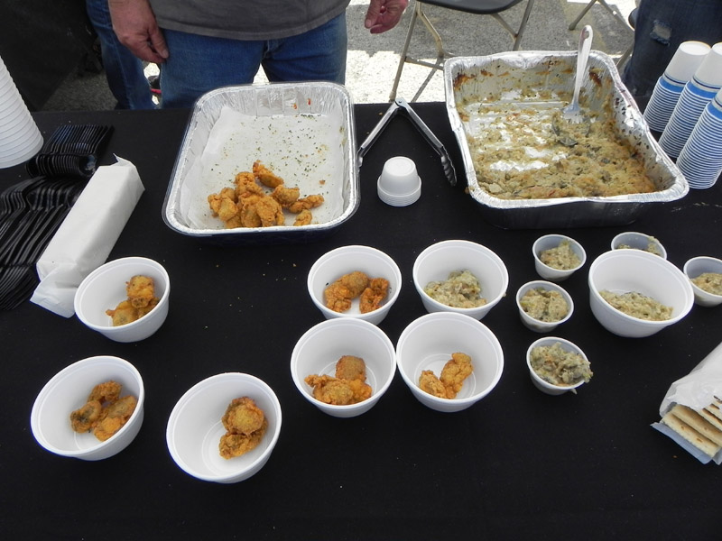
Fried with hot sauce
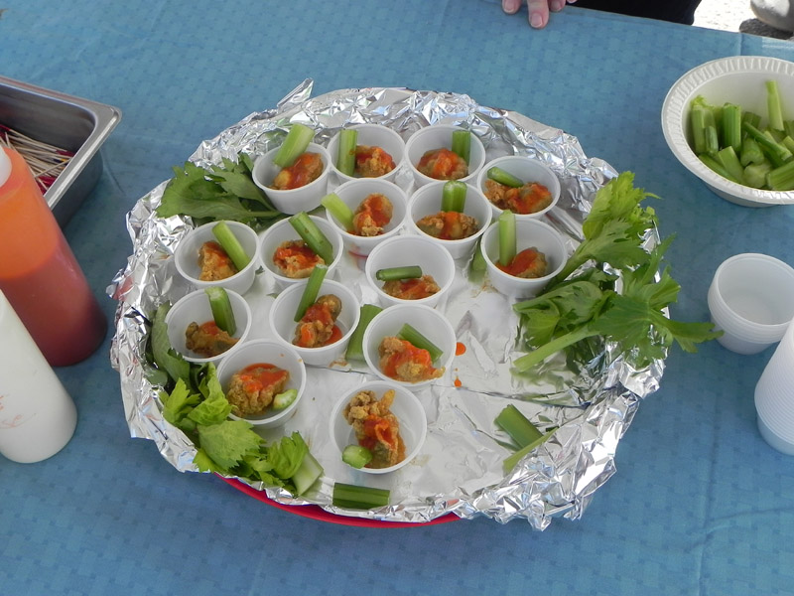
Buffalo oyster
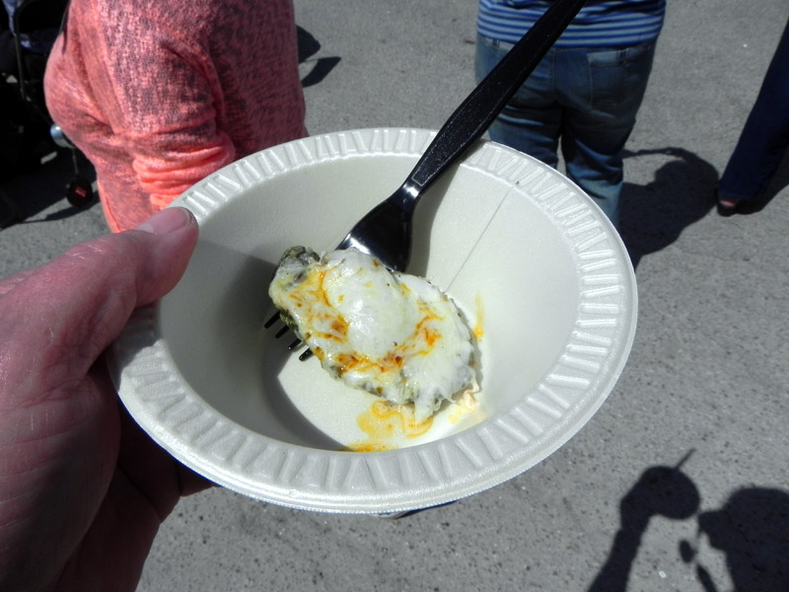
Oyster Lasagna
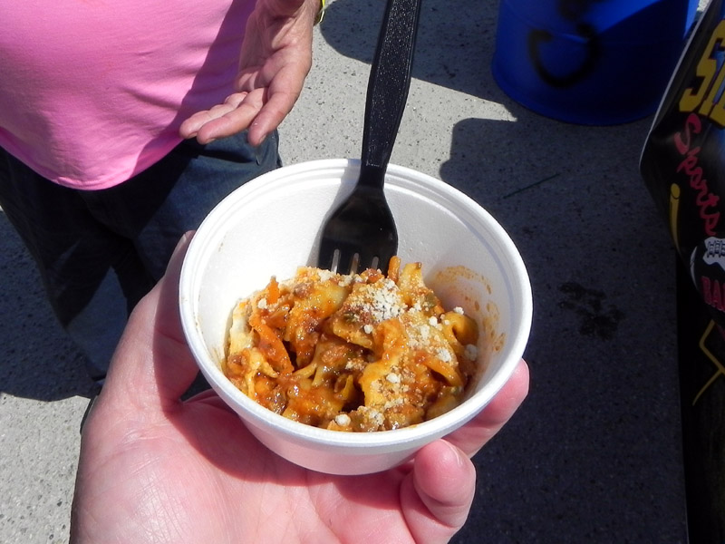
The winner was this – Tony’s Seafood Creole Oyster Bisque
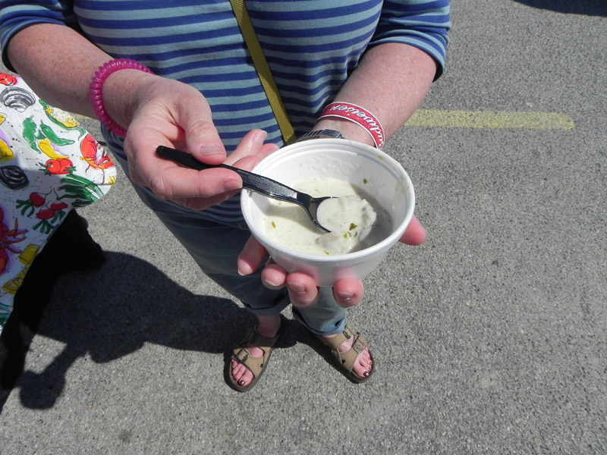

My wife the groupie hitting on the live entertainment
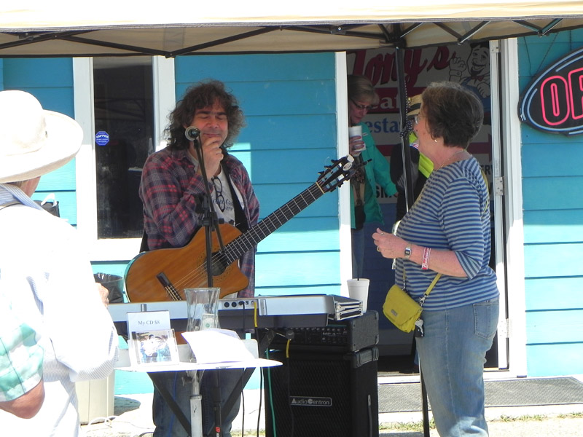
These are $4.99/lb about 10 minutes away.
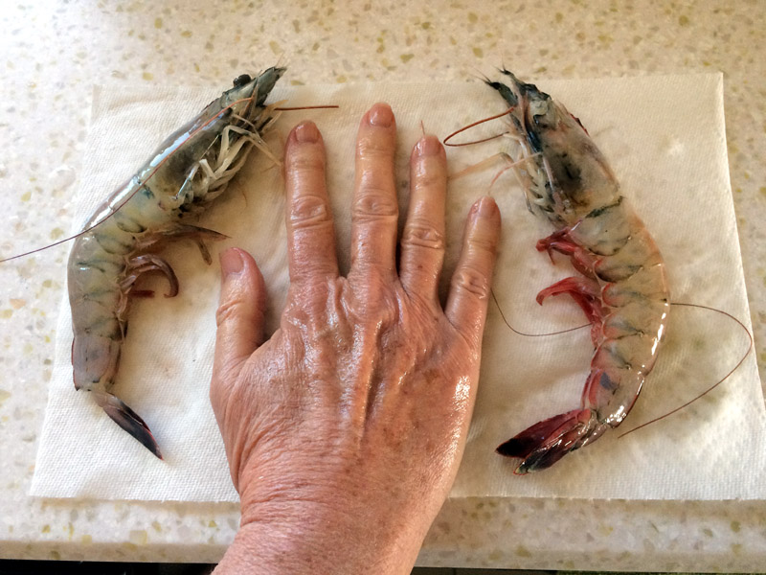
These are $2.99/lb
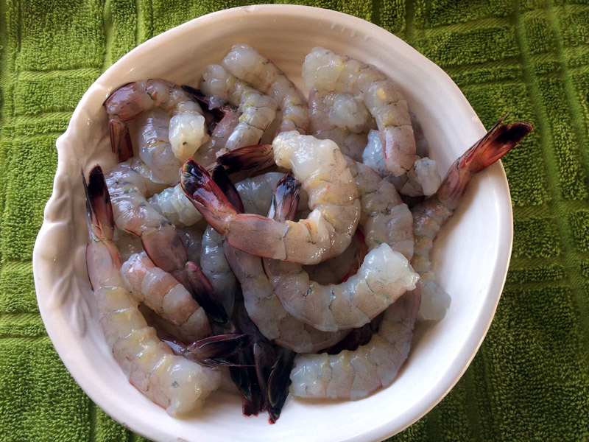

World Meat Pie Eating Championship - the Silver Slipper Casino hosted this contest. Professional eaters (anyone looking for a job?) from all over the country came to compete. Joey Chestnut, famous for his record with Nathan's hot dogs, is now the world meat pie eating champ, too. This was truly a carnival type of event complete with barker. Lots of fun, too. A video is here.
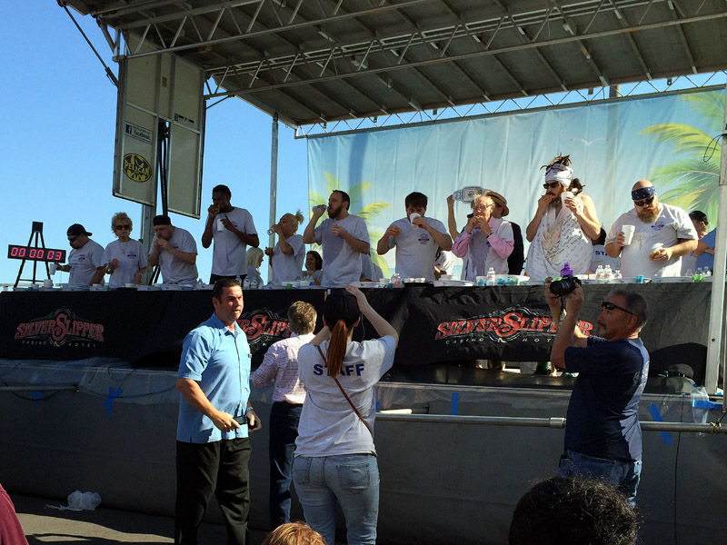
St Patrick's – Here’s the pre-parade couple looking for the fun.
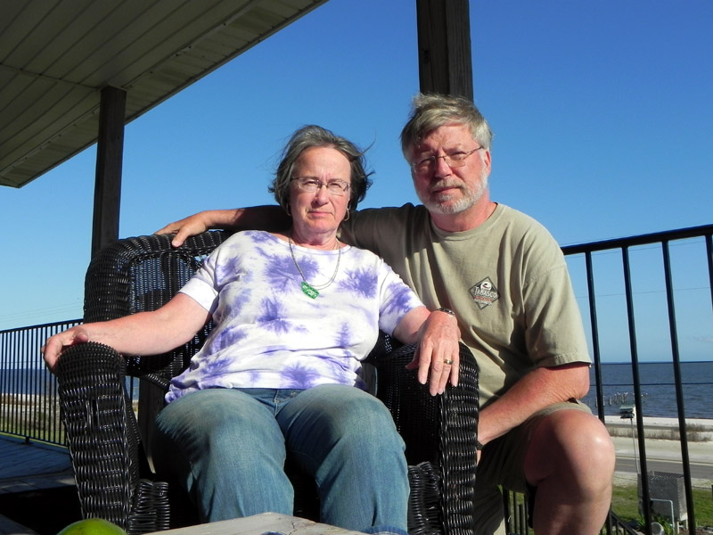
Post-parade bejeweled couple
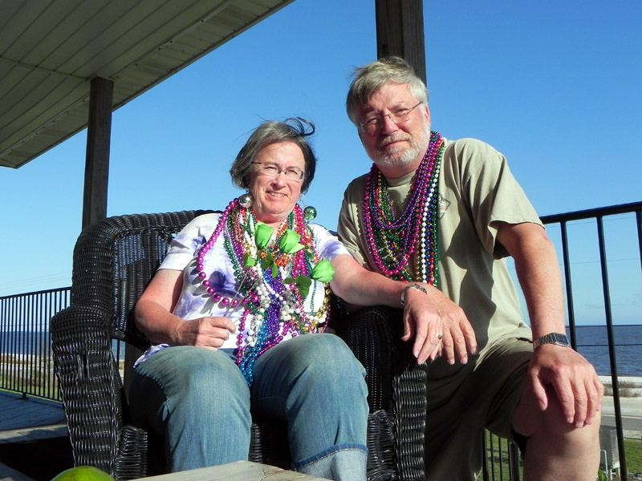
They found the fun, and the bling! 25+ pounds of jewels, plus 3 roses, 1 shot glass, 6 cabbages, 2 potatoes, 1 carrot, and a lime. We can make Irish stew and look glamorous, but where's the gin?

Our "haul" was moderate by local standards. Those who knew what was going to happen were there with grocery bags and wagons. We gave the lady next to us 5 of our cabbages; she collected another 10 or 12 (for a pig roast, she said). There seemed to be no end to the food and trinkets they had to toss to the crowd. Now, that was a parade!
.
